
#Decodethecode
Netflix's newest popular show – Adolescence – has brought to light the issues surrounding the online security and safety of your child/teenager. Online, young people are communicating in ways that most adults completely misunderstand. What looks innocent could potentially have a very different meaning.
Here are some of the 'codes' which may be being used by your child:

Red Pill – “I see the truth.” Used in toxic male spaces to mean waking up to supposed hidden ‘truths’ about women and society, often linked to misogynistic ideologies.
Blue Pill – Represents those who are “blind to the truth” or still believe in mainstream views about relationships and gender dynamics.
Dynamite Emoji – An “exploding red pill,” meaning someone is a radicalised incel.
Kidney Bean – A symbol linked to incel culture, sometimes mocking women.
100 Emoji – Tied to the “80/20 rule,” the belief that 80% of women are only attracted to 20% of men.
Black Hole – Used to express depression, hopelessness, or being sucked into negative online spaces.
Tornado – Represents chaos or feeling overwhelmed, sometimes used to indicate mental distress.
Frog Emoji – Associated with alt-right and extremist meme culture, often linked to Pepe the Frog, which has been co-opted by some toxic online groups.
Eagle – A symbol of extreme nationalism, sometimes used in far-right online spaces.
Skull – While often just slang for “that’s funny” or “I’m dead (from laughing),” in certain groups, it can signal darker themes like nihilism or self-harm.

Heart colours and what each one can represent.

= Love
= Lust
= “Are you interested?”
= Interested but not in sex
= “You’ll be okay”

So, what should parents do and some advice?
Get Curious, Not Combative – Ask open-ended questions: “I saw something about emojis meaning different things. Have you heard of this?” Keep the conversation light.
Create a Judgment-Free Zone – If your child feels like they’ll be punished for opening up, they won’t. Make it clear you’re there to listen, not just lecture.
Decode Together – Ask them to explain their digital world. What do different symbols mean? Who are the influencers they follow? Don’t assume—ask.
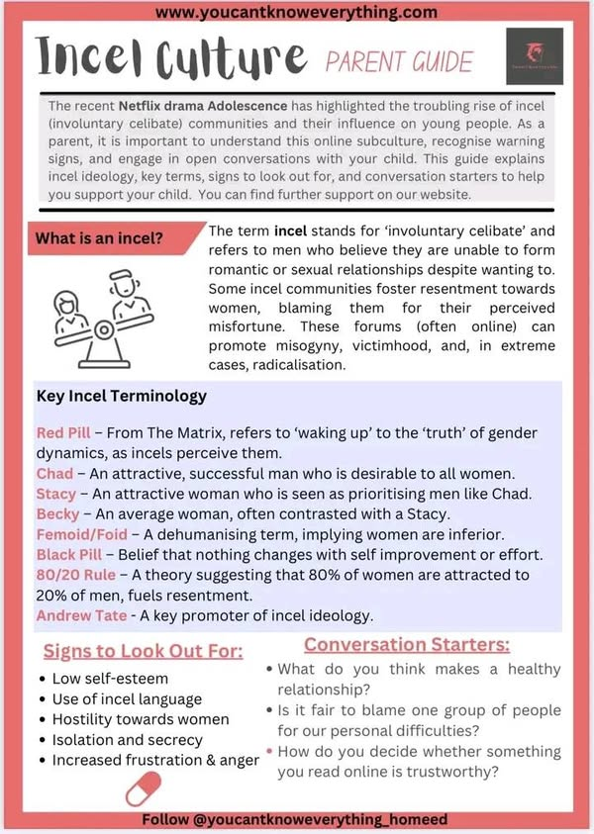
4
Teach Critical Thinking – Help them question online content. “Why do you think some groups push this idea? Who benefits?” Arm them with questions, not just rules.
Monitor Without Spying – Open conversations work better than secret surveillance. Make checking in on their online spaces a normal part of parenting, not a crisis move.
Be Real About Manipulation – Explain how toxic online groups groom young people by making them feel special, included, or like they have ‘insider knowledge.’
Build Their Offline Confidence – The more they feel valued and confident in the real world, the less they’ll seek validation in dangerous online spaces.

The digital world is evolving faster than most adults can keep up. But we don’t have to be in the dark!
#DecodeTheCode #ProtectThem #OnlineSecurity #OnlineSafety #SaveALife #TheWayTheyCommunicate #CR2Security

Sources:
- https://www.cr2security.com/news/online-safety-awareness-cr2-securitys-commitment-to-youth-awareness-and-protection
- www.youcantknoweverything.com

